How to download Office 365

Students at Methodist College have access to Office 365 at no cost while attending the College. To download and install the software, take the following steps:
- Open a browser and go to www.office.com
- Log in with your student email and password, the same as you’d use for Email and D2L
- Once logged in, near the upper right there will be an “Install Office” link:
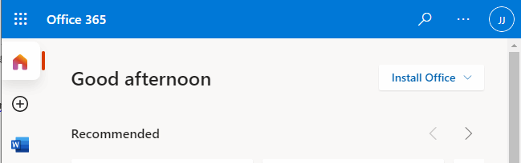

- Click this link and choose the “Install Office 365 Apps” button:
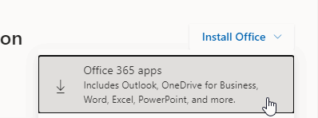

This will download the installer. Once it finishes, go to your downloads folder, run it and follow the prompts. When asked to sign in and activate, use your methodistcol.edu email address and password. Once installed, the subscription will stay active until a few weeks after graduation. At this time, if you still have office installed, you will want to sign out or it will start giving subscription errors. Any documents you have stored locally on your PC will still be yours, however, anything stored in OneDrive will no longer be accessible and your Email account will shut down. Please be mindful of this and save anything important you will want to keep before graduation.

